Session 4 -1

import java.io.*;
import java.util.*;

public class Solution {

public static void main(String[] args) {
Scanner s = new Scanner(System.in);
int t = s.nextInt();
String [] pair_left = new String[t];
String [] pair_right = new String[t];

for (int i = 0; i < t; i++) {
pair_left[i] = s.next();
pair_right[i] = s.next();
}

HashSet<String> set = new HashSet<>();
for (int i = 0; i < t; i++) {
set.add(pair_left[i] + " " + pair_right[i]);
System.out.println(set.size());
}
s.close();
}
}

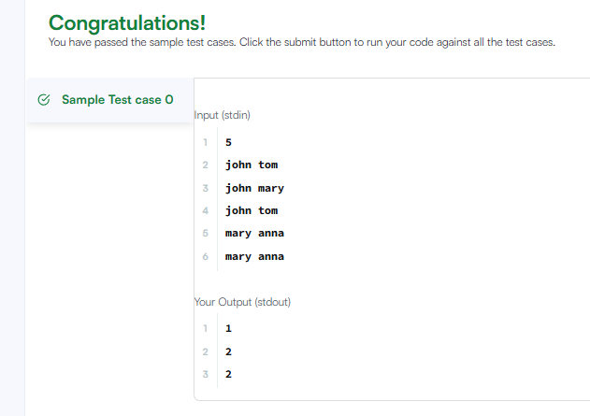

Session 4 -2

import java.util.*;

interface Food {
public String getType();
}

class Pizza implements Food {
public String getType() {
return "Someone ordered Fast Food!";
}
}

class Cake implements Food {
public String getType() {
return "Someone ordered a Dessert!";
}
}

class FoodFactory {
public Food getFood(String order) {
if (order == null) {
return null;
}
if (order.equalsIgnoreCase("pizza")) {
return new Pizza();
} else if (order.equalsIgnoreCase("cake")) {
return new Cake();
}
return null;
}
}

public class Solution {
public static void main(String args[]) {
Scanner sc = new Scanner(System.in);
FoodFactory foodFactory = new FoodFactory();
Food food = foodFactory.getFood(sc.nextLine());
System.out.println("The factory returned " + food.getClass());
System.out.println(food.getType());
sc.close();
}
}

